SWU Incoming Exchange Student Information Sheet
Academic Year 2019

1. Academic Calendar (Tentative Schedule)

 | Spring Semester 2019 | Fall Semester 2019
Nomination Deadline | November 16, 2018 | May 17, 2019
Application Deadline | November 30, 2018 | May 31, 2019
Recommended Arrival Date | Around March 28~30 | Around September 18~20
Orientation Dates | April 2~6 | September 21~28
Classes Start | April 8 | October 1
Classes End | August 7 | February 8
Vacation During Semester | Summer Vacation:  August 9~September 30 | Winter Vacation:  December 22~January 5  Spring Vacation:  February 8~March 31
Transcript Issue | After October | After April
*Semester schedule is subject to change without notice.

2. Exchange Program Information
There are 2 non-degree semester programs for international students to choose from, depending on their Japanese language proficiency.

SWU Academic Program (Advanced Level)
Language requirement | N2 level on the Japanese-Language Proficiency Test (JLPT) or above  *Student should submit the JLPT certificate when applying.
Courses / Credits | -Students should take at least 7 courses (up to 10 courses).  (language courses are worth 1 credit, and liberal arts courses are worth 2 credits per course)  -Students choose from a list of courses open to international students (Japanese language and liberal arts courses).  -Students register for classes during orientation period.  -List of recommended courses can be found at: http://cie.swu.ac.jp/english/prospective/exchange/  -Course syllabus search website: (in Japanese)  https://up.swu.ac.jp/unipa/faces/up/co/Com02401A.jsp  *Not all courses are open to international students.

Intensive Japanese Language Program (Intermediate Level)
Language requirement | Must have studied basic Japanese (JLPT N3 level or CEFR A2 level recommended) before arrival.
Courses / Credits | -Students take 5 mandatory Japanese language courses.  (worth total of 8 credits)  *Course details are on the CIE website and program brochure.  -Students may take up to 2 elective liberal arts courses (English or Japanese *depending on students’ Japanese level) open to participants of this program.  -Students register for classes during orientation period.
3. Accommodation Information
There are 3 types of housing near the university campus and other off-campus dormitories.
 | SWU Gakusei-Kaikan | SWU International House | Other Off-campus Dormitories
Access | 3 min walk from campus | 3 min walk from campus | 30~40min commute by train
Type | Three-bedroom apartment style room shared with 2 students  (approx.72㎡) | -Single apartment style room (approx. 20㎡) | Single room with shared facilities
Room Facility | Bed, desk & chair, A/C, Closet, Bathroom, Shower-room, Kitchen, Fridge, Microwave | Bed, desk & chair, A/C, Closet, Bathroom, Shower-room, Kitchen, Fridge, Microwave | Bed, desk & chair, A/C, Closet
Monthly  Rent | JPY 65,000/person  (Utility costs included) | JPY 53,000/person  (Utility costs included) | Approx.  JPY 50,000~60,000/person  (Utility costs included)
Food | Approx. 25,000 Yen *  (Estimated cost for meals)
Transportation | JPY 0 | JPY 0 | Approx. JPY 3,000  (Depend on Accommodation)
Note | Two other roommates are Japanese students. |  | Bathroom, Shower-room, Kitchen, Laundry, and Dining are shared.
* Some off-campus dormitories provide meals (breakfast and dinner on weekdays)

NOTE
We might not be able to meet your accommodation preferences chiefly due to the limit in the number of rooms available of each accommodation.

4. Events and Support
There are a variety of events and support for exchange students.
Seasonal Events | SWU offers events, activities and field trips for students to experience Japanese culture and customs.  e.g.) - International Students’ Welcome Party  - Hiking at Mt. Takao  - Camping with Japanese students  - Hatsu-Mode (Visit to shrine during New Year season)  - Visit to student club activities (Tea Ceremony, Kimono-fitting, etc…)
Host Sister | A student volunteer will help international students settle in and start their school life in Japan.  <Things Host Sister can help with>  - Airport Pick-up (dates should be arranged by CIE)  *Students pay their own transportation fee from the airport  - Documentation at the ward office  - Opening a bank account  - Buying daily necessities, etc…
5. VISA and Health Insurance
There are some important procedures students are required to carry out when arriving to Japan.
Residence Card  *Mandatory | When students enter Japan with their student visa, they will receive a “Residence Card.” This card notes students’ visa status, period of stay and other information related to residency.  Within 2 weeks after arrival, students are to carry out residency registration procedures at the local ward office.  Students are to carry this Residence Card at all times during their stay in Japan, and this card will be used to prove residency when opening a bank account, signing a contract for mobile phones, etc.
National Health Insurance  *Mandatory | All international students studying at SWU are required to become a member of the “National Health Insurance.” Students must apply at the National Health Insurance section of the ward office with their Residence Card and passport.  This insurance is valid throughout the students’ stay in Japan, and with this insurance students only have to pay 30% of the medical fee (some services such as health check-ups and special operations are not covered by the insurance). The monthly insurance premium differs based on the students’ ward of residence, but are usually about JPY 2,000/month.
My Number  *Mandatory | After students are registered as a local citizens, they will get Individual Number called "My Number".
Part-Time Work Permission | In order to start a part-time job, international students must apply for work permission Shikakugai katsudo kyoka (“Application for Permission to Engage in Activity Other Than That Permitted Under the Status of Residence Previously Granted”).  This can be done at the airport when entering Japan, and those who plan to work part-time are strongly recommended to apply for permission at the airport. Otherwise, students have to go to the Immigration Bureau later on their own. No fee is charged for the work permission.  <NOTE>  -International students can only work up to 28 hours per week, and up to 8 hours a day during school vacations.  -Work in the adult and gambling business is strictly prohibited.

6. Contact Information
Center for International Exchange (CIE) | Website for International Students
Associate Coordinator | http://cie.swu.ac.jp/english/prospective/
Mitsuhiro Kurakata (Mr.)
MAIL: cie@swu.ac.jp
TEL: +81-3-3411-5249 | 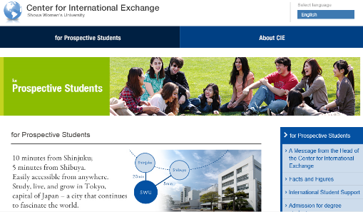
FAX: +81-3-3411-6973
1-7-57 Taishido, Setagaya-ku
Tokyo 154-8533, JAPAN
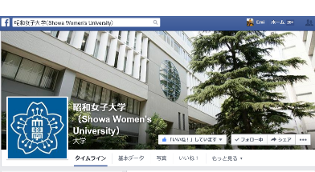
"Like" us on Facebook!
https://www.facebook.com/ShowaJoshi(The page is in Japanese)
You can check our university events and activities and updated blog-posts by each departments.

